|  |
| --- |
| DMIT2590 – Capstone |
| NAIT Crystal Ball System Documentation |
|  |

|  |
| --- |
| Team 5K:  Xin Du, Yang Liu, Kyle Gibson, Ashley Condie, Briand Rabideau  Instructor: Gerry Schenk  Section: A03 |

Table of Contents

INTRODUCTION 4

***1.1 About NAIT*** 4

***1.2 System Purpose*** 4

PROBLEM / VISION STATEMENT 5

***2.1 Problem*** 5

***2.2 Vision Statement*** 5

***2.3 In-Scope Deliverables*** 5

***2.4 Stakeholders*** 6

***2.5 Out-Of-Scope Deliverables*** 6

ACTOR DESCRIPTIONS AND USE CASE DIAGRAM 7

***5.1 Actors*** 7

***5.2 Use Case Diagram*** 7

USE CASE NARRATIVES 8

***6.1 Select Pathway Map*** 8

***6.2 Find Program Matches*** 10

***6.3 Change Password*** 12

***6.4 Account Recovery*** 14

***6.5 Add Program*** 16

***6.6 Update Program*** 18

***6.7 Add High School Courses*** 20

***6.8 Update NAIT Courses*** 22

***6.9 Add Category*** 24

***6.10 Update Category*** 26

***6.11 Look up*** 28

***6.12 Add NAIT Courses*** 30

***6.13 Add Equivalencies*** 32

***6.14 Remove Equivalency*** 34

ENTITY RELATIONSHIP DIAGRAM 36

DATA FLOW DIAGRAM 37

CLASS DIAGRAM 38

SUMMARY AND RECOMMENDATIONS 39

***9.1 Summary*** 39

***9.2 Recommendations*** 39

PROJECT PLAN 40

GLOSSARY 42

# INTRODUCTION

## 1.1 About NAIT Crystal Ball

NAIT Crystal Ball is an application that assists current and prospective students in selection the program that is right for them .The system allows a user to enter their education and preferential information, which will result in a list of relevant programs that might be a good fit and any credits they may be eligible to receive. Furthermore, the system allows NAIT staff to add entrance requirements, preference question parameters, course equivalencies, and other parameters that will allow the system to properly match programs.

## 1.2 System Roles

The system contains two primary user roles that differentiate the amount of information displayed and the level of interactivity the user can access.

**Administrator**

The administrator is responsible for maintaining a wide range of courses and peripheral course information that is essential for the system to correctly find program matches for non-admin users. This is accomplished through a variety of menus that allow the administrator to modify program information, course information, entrance requirements, course equivalencies, and so on. This role will be assigned to a single user account where the login information can be provided to staff at NAIT’s discretion. All of the administrator pages will be covered in depth in the walkthrough section.

**Student**

The student only has access to academic pathways searches, which is the primary function of the system. They will be asked to provide their academic profile, including high school and post-secondary courses, and their preferences for a potential career. Based on the data provided the system will then sort through the programs in the database and attempt to find the best possible matches for the student. These results are displayed in a list that give a brief description of the program, the percent match to the student’s preferences, any credit they may receive from previous courses, and a link to the program page on the NAIT website.

# System Walkthrough

## 2.1 Administrator

The administrator has access to a wide variety of content management pages that will have a direct influence on the functionality of the NAIT Crystal Ball system. They are as follows:

1. **Admin landing page** – this is the umbrella page that the administrator will see upon logging in and provides access to the wide variety of admin actions.  
     
   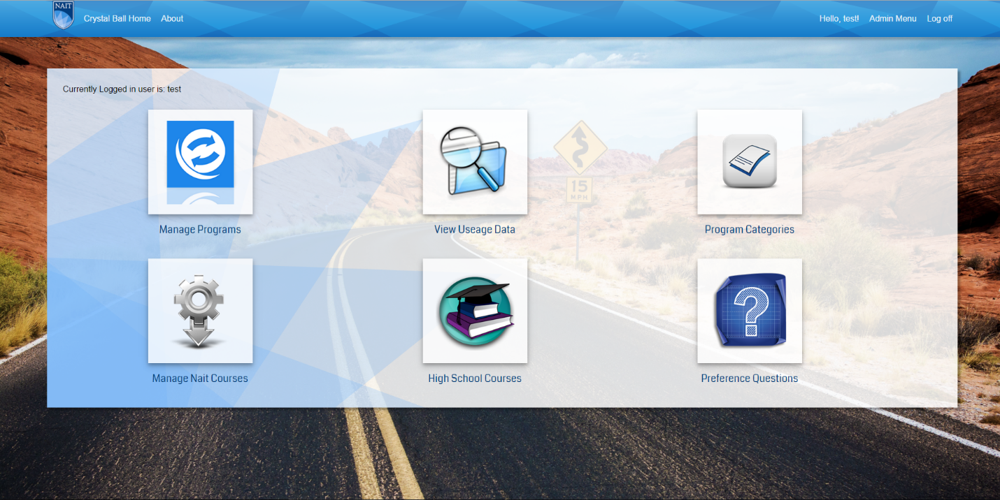
2. **Manage programs** – This page allows the administrator to manage programs including adding and updating. This section is comprised of the following sub-sections:  
   1. *Search Programs* – The administrator can search for a specific program or lookup all programs in a specific category.  
        
      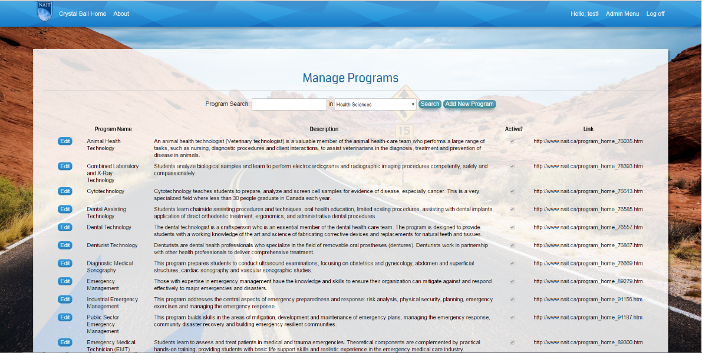
   2. *Manage Programs – Step 1: Manage Program Information* – The administrator can update the profile information including name, credential type, description, total credits, etc.  
        
      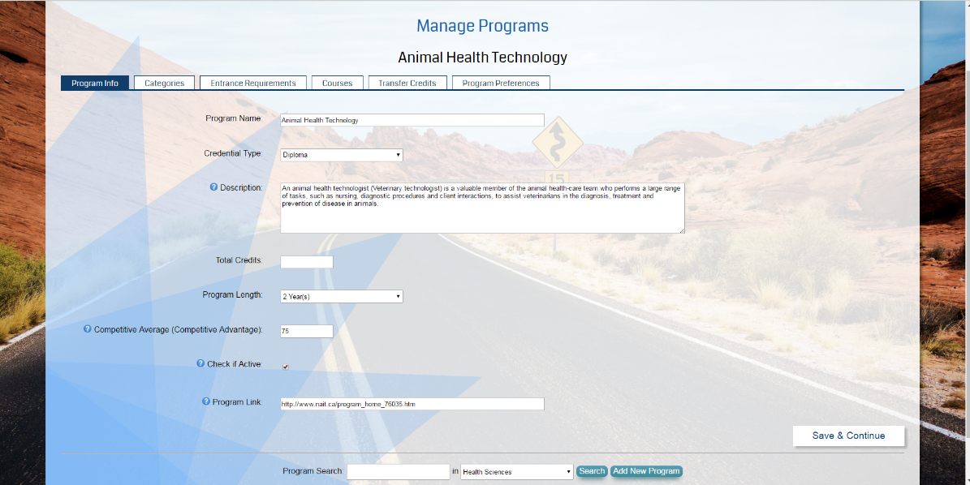
   3. *Manage Programs – Step 2: Set Program Category* – The administrator sets the program categories that the program belongs to. This will affect search results and how the program is retrieved in drop down lists.  
        
      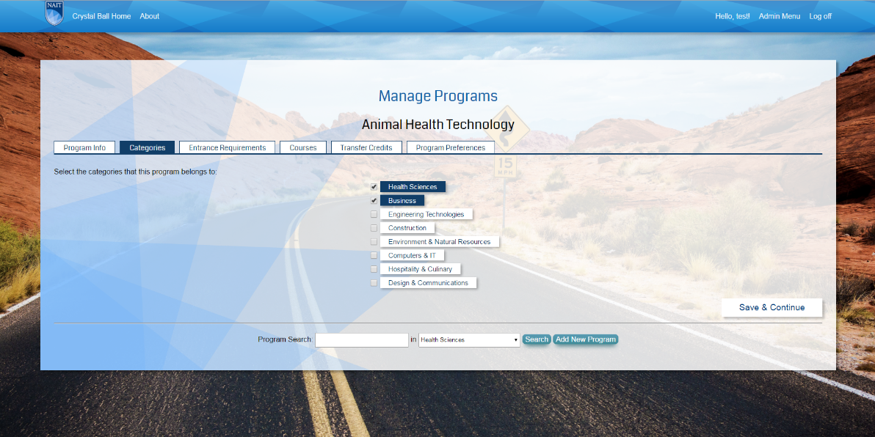
   4. *Manage Programs – Step 3: Set Program Entrance Requirements* – The administrator sets the entrance requirements for the program including high school courses and post-secondary courses (if relevant).  
        
      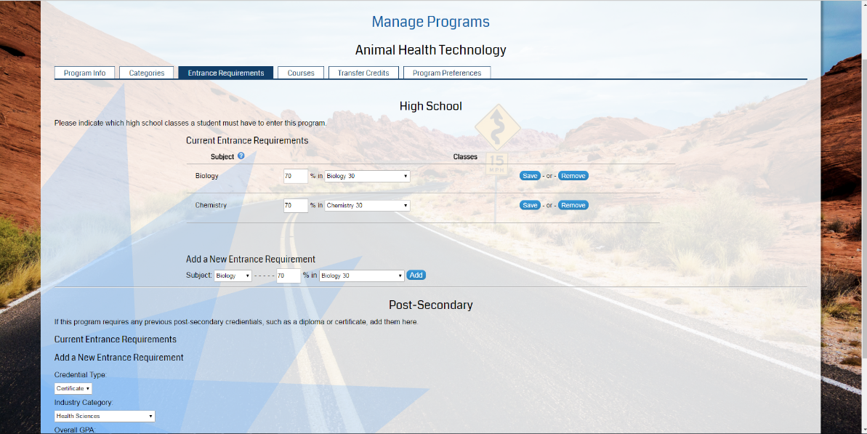
   5. *Manage Programs – Step 4: Add Program Courses –* The administrator sets what courses are part of the program.  
        
      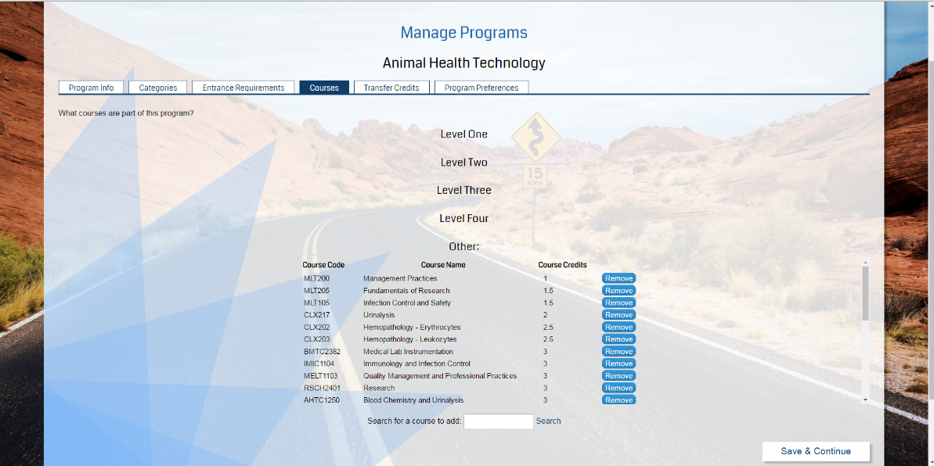
   6. *Manage Programs – Step 5: Set Transfer Credits* – If relevant, the administrator sets what courses are eligible for transfer credit and which courses provide said credit.  
        
      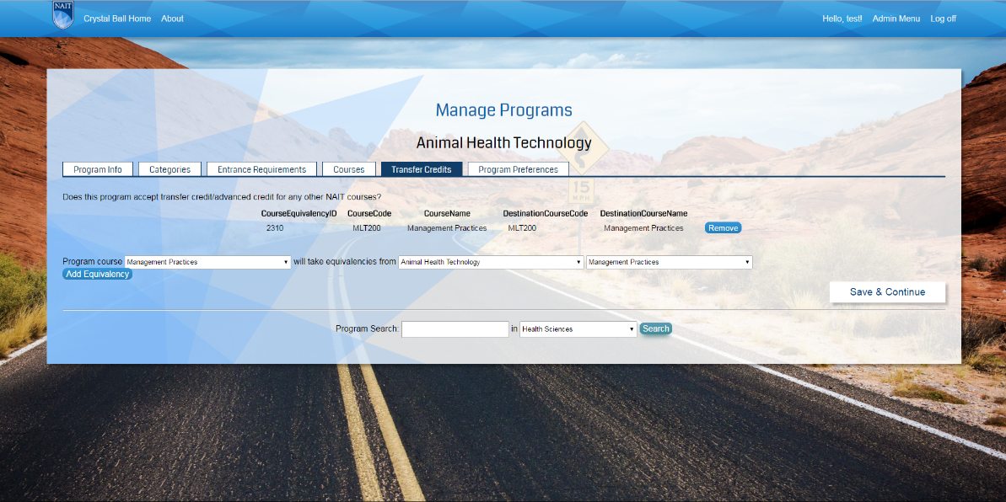
   7. *Manage Programs – Step 6: Set Program Preferences* – The administrator will set the expected program preferences that will result in a positive match between a prospective student’s preferences and the program preferences.  
        
      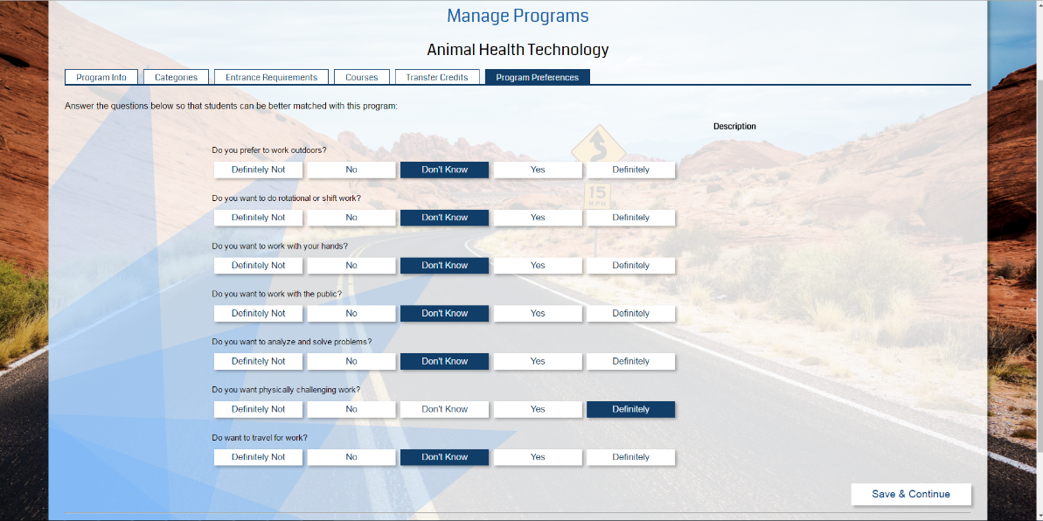  
        
      Once the administrator is satisfied with the parameters set for a particular program they can then be saved, which will update the database entry for that program. **Changes made to the program cannot be changed once saved without going through the whole process again.**
3. **Reporting (View Usage Data)** – This section allows the administrator to generate reports relating to metrics gathered by the system as it searches for results. This is broken into two sections:
   1. *Program Data –* This tab allows for generating reports relating to student metrics including the frequency a program was a search result, the percent of students who want to switch programs, and the type of program a student is currently enrolled in. The report generated is sorted by date and can be exported to a PDF.
   2. *Student Data –* This tab generates metrics based on the preference questions that were answered by students and aggregates all answers into a percentage. This data is sorted by date and provides details including the student’s semester (if applicable), change program status, and the percentage of answers provided to each preference question.
4. **Manage Categories –** This section allows for adding or updating the umbrella categories that programs will be a part of. Categories cannot be deleted as it is necessary to maintain outdated categories in case a prospective student has credit in a discontinued or altered program.  
     
   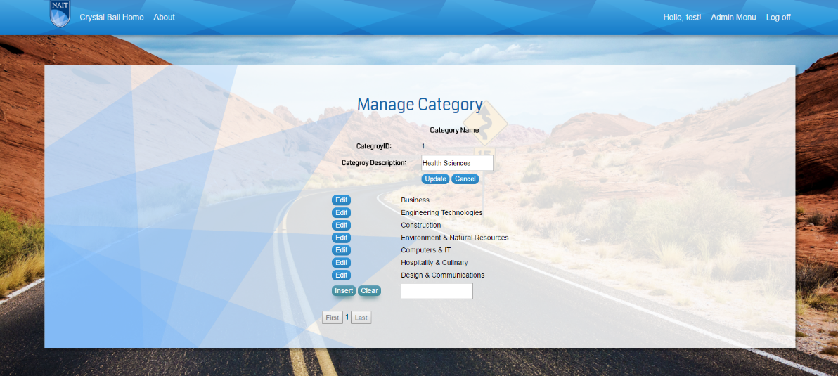
5. **Manage NAIT Courses –** This page allows the administrator to search for NAIT programs based on category and can modify existing programs or add new ones. When modifying or creating a program, the administrator is expected to provide a course code, course name, credit value, and whether the course is active or not.  
     
   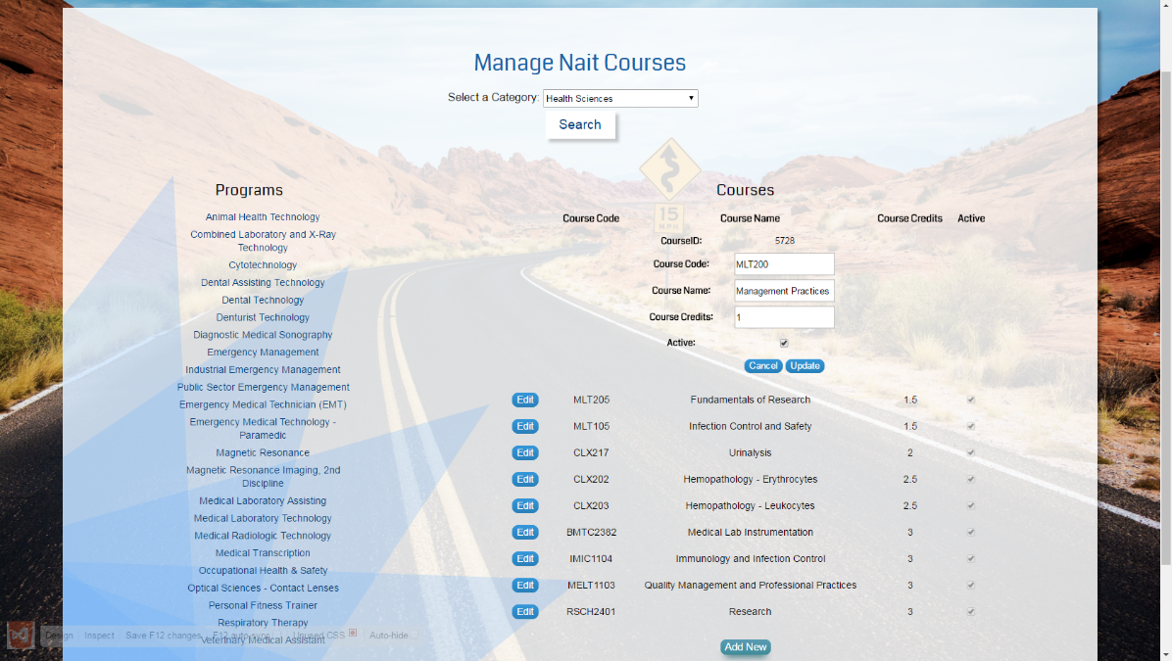
6. **Manage High School Courses** – This section allows the administrator to modify or add high school courses to the database. In addition to the course name, it is essential to provide the course category (Math, Science, etc.) and high school level of each course (1, 2, 3).  
     
   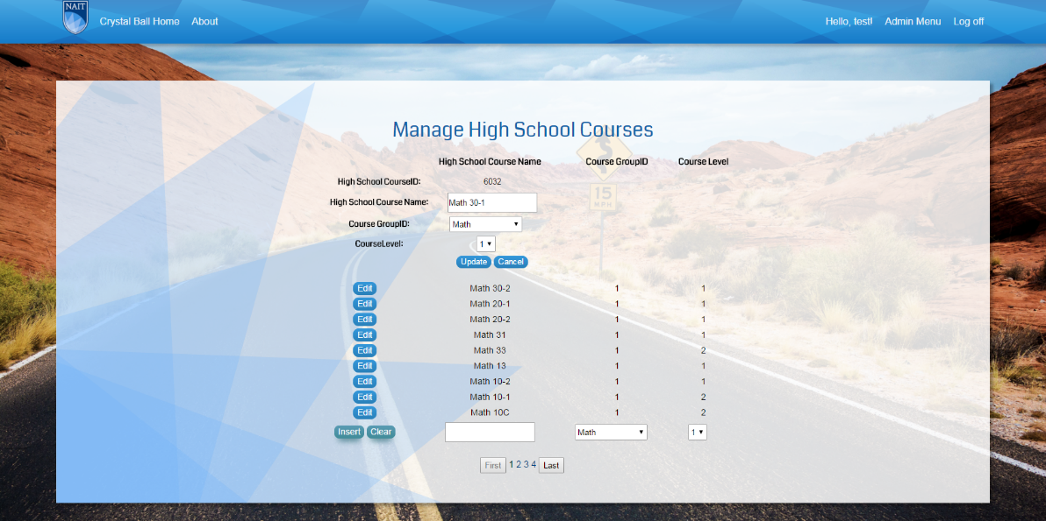
7. **Manage Preference Questions** – This section allows the administrator to add or modify preference questions stored in the database. The question IDs are automatically generated by the database but the user is expected to provide the question description and whether it is active or not.  
     
   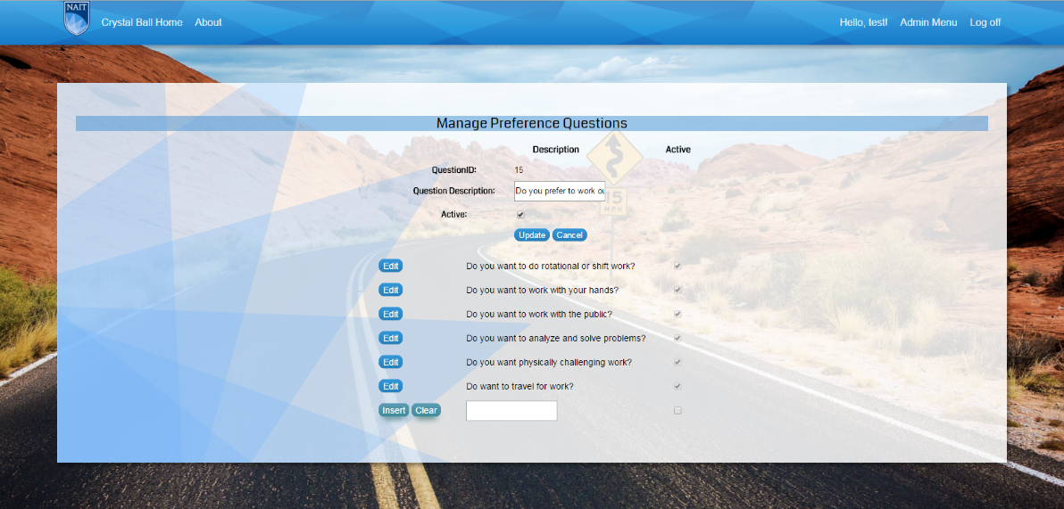

## 2.2 Student

Any user that does not log in will be considered a student and will only have access to the pathways search engine. When the search is initiated it will prompt the student for education and preference information through a series of steps, which are as follows:

1. **Select High School Courses (Optional)** – This page prompts the user to provide the high school courses they have taken and whether or not they have graduated from a post-secondary institution. This section will filter out courses where the user does not meet the high school entrance requirements, however it can be left blank and still retrieve results.  
   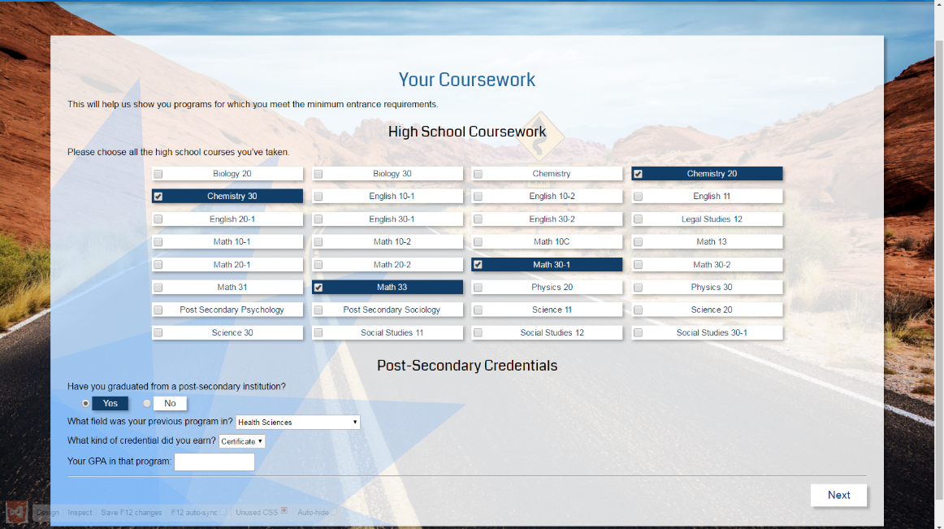
2. **Provide NAIT Education Background (Optional)** – If the user tells the system they are a NAIT student they must provide the program they are enrolled in, their semester, and whether they would like to switch programs. The system will autofill the core courses of the program they selected in the next step.  
     
   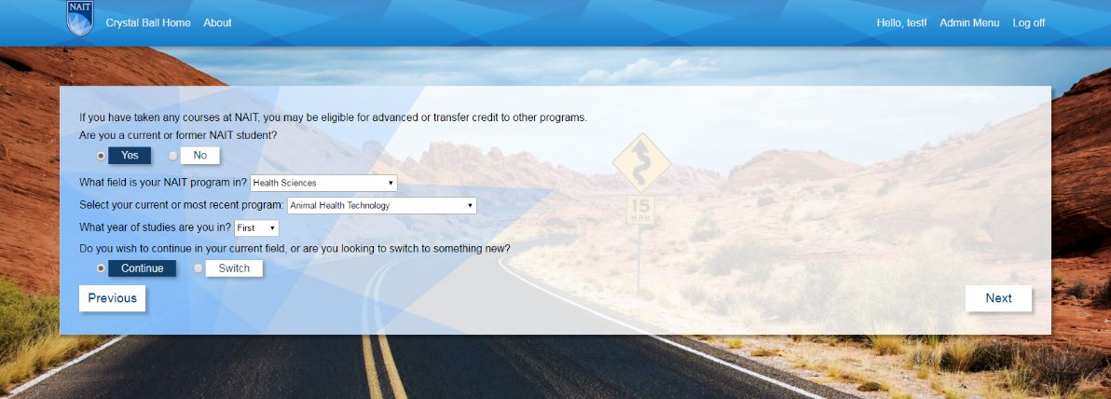
3. **Select NAIT Courses (Optional)** – If the user has indicated they are a NAIT student their course basket will be automatically filled with the core courses of the selected program. This section also allows the user to search for NAIT programs and add them to the course basket. This page will log the amount of courses that are selected and provides the option to delete individual courses from the basket or empty it entirely. The page is skipped if the user indicates they are not a NAIT student.  
     
     
   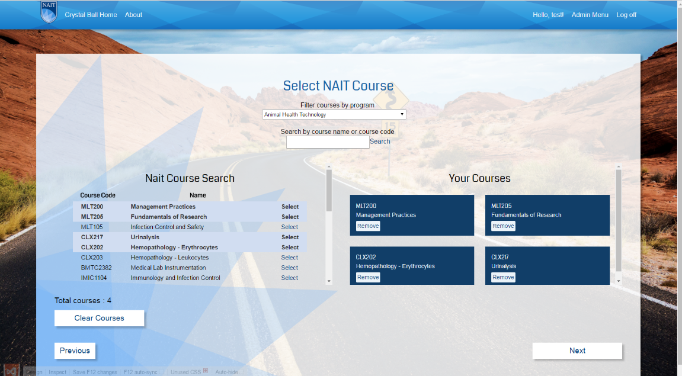
4. **Answer Preference Questions** – The user is prompted to answer a series of preference questions that will filter down the possible search results that will be displayed by the system. This section is technically optional but will default all answers to “don’t know.”  
     
   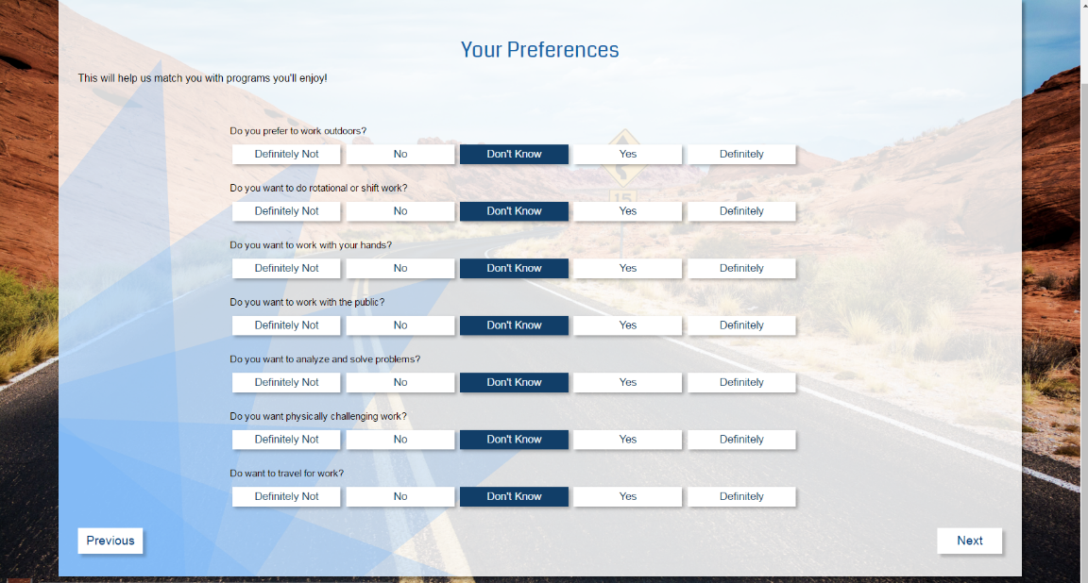
5. **Results Display** – After completing (or skipping) the other sections the system will search the database for possible matches and display them to the user. The system will also display the percent match based on the user’s responses and the transfer credit they may be eligible to receive. The user can then opt to view the NAIT webpage for each of the programs listed or search again.  
     
   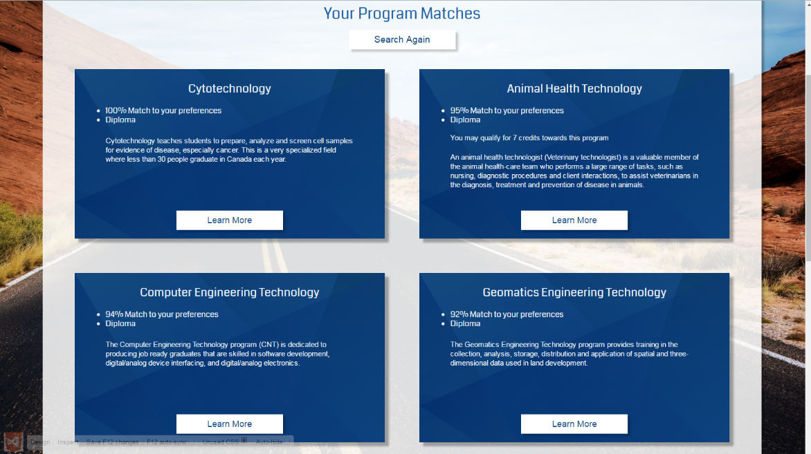

# ACTOR DESCRIPTIONS AND USE CASE DIAGRAM

## 5.1 Actors

* User—a person, usually a student, who is using the application to search for programs
* Admin—a NAIT staff member who is able to view reports and update program information

## 5.2 Use Case Diagram



# USE CASE NARRATIVES

## 6.1 Select Pathway Map

|  |  |  |
| --- | --- | --- |
| Use Case Name: | *Select pathway map* | |
| Description: | Student requests a pathway map and receives it | |
| Actor(s): | Student | |
| Normal flow of events: | Actor action | System Response |
| 1. Student selects a pathway map | 1. System returns the chosen pathway map |
| Outstanding Issues: |  | |
| Business Rules: | Course data is stored in the cache  Preference Question tallies are used for reporting | |



Figure 1: Select Pathway Map

## 6.2 Find Program Match

|  |  |  |
| --- | --- | --- |
| Use Case Name: | *Find program match* | |
| Description: | Student inputs information and gets program match | |
| Actor(s): | Student | |
| Normal flow of events: | Actor action | System Response |
| 1. Student answers preference questions 2. Student enters their completed high school courses | 1. System stores courses in the cache 2. System displays results screen based on student answers |
| Outstanding Issues: |  | |
| Business Rules: | Course data is stored in the cache | |



Figure 2: Find Program Matches

## 6.3 Change Password

|  |  |  |
| --- | --- | --- |
| Use Case Name: | *Change password* | |
| Description: | Admin changes their password | |
| Actor(s): | Admin | |
| Normal flow of events: | Actor action | System Response |
| 1. Admin logs in 2. Admin enters old password for verification and inputs new password | 1. The password is changed |
| Outstanding Issues: |  | |
| Business Rules: | Only one admin account exists as all programs will share one account | |



Figure 3: Change Password

## 6.4 Account Recovery

|  |  |  |
| --- | --- | --- |
| Use Case Name: | *Account recovery* | |
| Description: | Admin forgets their password and needs to change it | |
| Actor(s): | Admin | |
| Normal flow of events: | Actor action | System Response |
| 1. Admin enters admin username | 1. System returns the password |
| Outstanding Issues: | How is the password returned? (Email/ Security Question) | |
| Business Rules: | Dependent on outstanding issues | |



Figure 4: Account Recovery

## 6.5 Add Program

|  |  |  |
| --- | --- | --- |
| Use Case Name: | *Add program* | |
| Description: | Admin adds a program | |
| Actor(s): | Admin | |
| Normal flow of events: | Actor action | System Response |
| 1. Admin adds program information to system | 1. A program is added to the system |
| Outstanding Issues: |  | |
| Business Rules: |  | |



Figure 5: Add Program

## 6.6 Update Program

|  |  |  |
| --- | --- | --- |
| Use Case Name: | *Update Program* | |
| Description: | Admin updates a program | |
| Actor(s): | Admin | |
| Normal flow of events: | Actor action | System Response |
| 1. Admin updates the program by adding, updating or removing entrance requirements | 1. Entrance adjusts program requirements |
| Outstanding Issues: |  | |
| Business Rules: |  | |



Figure 6: Update Program

## 6.7 Add High School Course

|  |  |  |
| --- | --- | --- |
| Use Case Name: | *Add high school course* | |
| Description: | Admin adds high school course | |
| Actor(s): | Admin | |
| Normal flow of events: | Actor action | System Response |
| 1. Admin enters high school course information | 1. High school course is added to the database |
| Outstanding Issues: |  | |
| Business Rules: |  | |



Figure 7: Add High School Course

## 6.8 Update NAIT Courses

|  |  |  |
| --- | --- | --- |
| Use Case Name: | *Update NAIT course* | |
| Description: | Admin updates a NAIT course | |
| Actor(s): | Admin | |
| Normal flow of events: | Actor action | System Response |
| 1. Admin updates the NAIT course credit and / or course name | 1. NAIT course is updated |
| Outstanding Issues: |  | |
| Business Rules: |  | |



Figure 8: Update NAIT Course

## 6.9 Add Category

|  |  |  |
| --- | --- | --- |
| Use Case Name: | *Add Category* | |
| Description: | Admin adds a category | |
| Actor(s): | Admin | |
| Normal flow of events: | Actor action | System Response |
| 1. Admin creates a new category | 1. A new category is added into the system |
| Outstanding Issues: |  | |
| Business Rules: |  | |



Figure 9: Add Category

## 6.10 Update Category

|  |  |  |
| --- | --- | --- |
| Use Case Name: | *Update Category* | |
| Description: | Admin updates a category | |
| Actor(s): | Admin | |
| Normal flow of events: | Actor action | System Response |
| 1. Admin updates a category | 1. The category is updated in the system |
| Outstanding Issues: |  | |
| Business Rules: |  | |



Figure 10: Update Category

## 6.11 Look up

|  |  |  |
| --- | --- | --- |
| Use Case Name: | *Look up* | |
| Description: | Admin or student looks up information in the database | |
| Actor(s): | Admin, Student | |
| Normal flow of events: | Actor action | System Response |
| 1. Admin or user does a lookup on one of the following:    * Pathway Map    * Program    * High School Course    * NAIT Course    * Category   (These are all part of a single interface) | 1. The system returns information matching the search criteria |
| Outstanding Issues: |  | |
| Business Rules: |  | |



Figure 11: Lookup

## 6.12 Add NAIT Courses

|  |  |  |
| --- | --- | --- |
| Use Case Name: | *Add NAIT course* | |
| Description: | Admin adds NAIT course | |
| Actor(s): | Admin | |
| Normal flow of events: | Actor action | System Response |
| 1. Admin enters NAIT course | 1. NAIT course is added to the database |
| Outstanding Issues: |  | |
| Business Rules: |  | |



Figure 12: Add NAIT Courses

## 6.13 Add Equivalencies

|  |  |  |
| --- | --- | --- |
| Use Case Name: | *Add NAIT course equivalency* | |
| Description: | Admin adds NAIT course equivalency | |
| Actor(s): | Admin | |
| Normal flow of events: | Actor action | System Response |
| 1. Admin enters NAIT course code and the equivalent course code | 1. Equivalency is added to the database |
| Outstanding Issues: |  | |
| Business Rules: |  | |



## 6.14 Remove Equivalency

|  |  |  |
| --- | --- | --- |
| Use Case Name: | *Remove NAIT course equivalency* | |
| Description: | Admin removes NAIT course equivalency | |
| Actor(s): | Admin | |
| Normal flow of events: | Actor action | System Response |
| 1. Admin selects NAIT course equivalency to remove | 1. Equivalency is removed from the database |
| Outstanding Issues: |  | |
| Business Rules: |  | |



## 6.15 Manage Degree Entrance Requirement

|  |  |  |
| --- | --- | --- |
| Use Case Name: | *Manage Degree Entrance Requirement* | |
| Description: | Admin adds, updates, or deletes a degree entrance requirement | |
| Actor(s): | Admin | |
| Normal flow of events: | Actor action | System Response |
| 1. Admin adds, updates, or deletes a degree entrance requirement | 1. The system alters the degree entrance requirement table appropriately |
| Outstanding Issues: |  | |
| Business Rules: |  | |



## 6.16 Manage Preference Question

|  |  |  |
| --- | --- | --- |
| Use Case Name: | *Manage Preference Question* | |
| Description: | Admin adds, updates, or deletes a preference question | |
| Actor(s): | Admin | |
| Normal flow of events: | Actor action | System Response |
| 1. Admin adds, updates, or deletes a preference question | 1. The system alters the preference questions table appropriately |
| Outstanding Issues: |  | |
| Business Rules: |  | |



# ENTITY RELATIONSHIP DIAGRAM



# DATA FLOW DIAGRAM



# CLASS DIAGRAM



# SUMMARY AND RECOMMENDATIONS

## ***9.1 Summary***

The scope and purpose of this project is to expand on phase I of the Pathways project and provide a system that will allow current NAIT students to explore their academic options. These pathways will be demonstrated to users through a visual interface that filters their options based on academic data the user inputs into the system. Research has been done and interviews conducted to determine the project requirements and outcomes that will determine if the project is successful. The goal is to have this application implemented by April 2016.

## ***9.2 Recommendations***

In order to complete the development of the Crystal Ball project, we recommend that user testing begin on the current prototype. This will provide the development team with valuable feedback and data to further improve the project and create the most user-friendly end product. Testing should be performed by current students from multiple programs across NAIT along with prospective students. These testers will access the student side of the site.

Members of the NAIT administrative staff that will be using the system are requested to test the administrative side of the site. All testers will be expected to give feedback regarding their personal experience with the site – determining the level of usability, any issues they had, and general likes and dislikes. The feedback received will allow for improved prototypes for further testing and refinement. To achieve the recommended testing, a meeting with the client should first occur to identify the most appropriate parties to test the system.

The client should also continue to be in frequent communication with the development team to ensure that the project meets the business requirements requested, and to ensure that development remains both on track and within scope.

# PROJECT PLAN

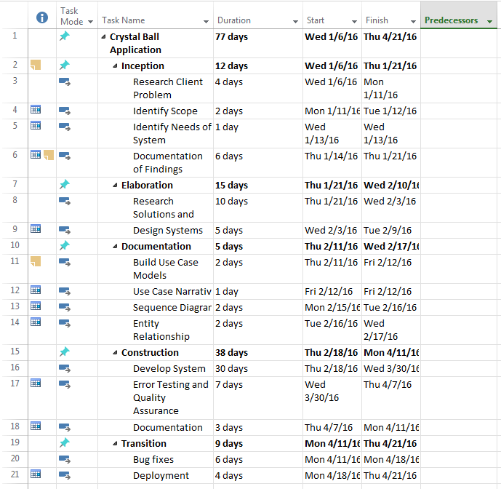

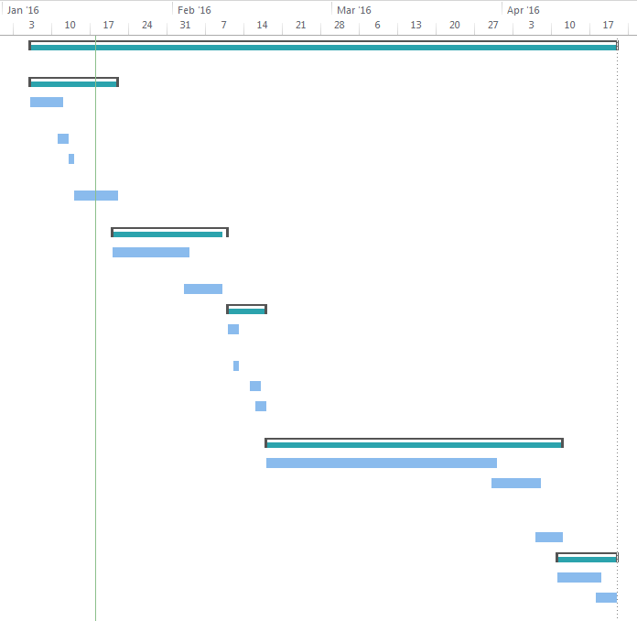

# GLOSSARY

***Note: The report document for Pathways Phase I was referenced during the creation of this document as there are many shared outcomes and project requirements between the two projects.***

**A**

Actor - Someone or something that has a specified role or interacts with the system.

ASP.NET - A programming language developed by Microsoft that is used in developing webpages that connect easily to a database.

**C**

C# - A programming language developed by Microsoft and is widely used within industry.

Category – The category that a particular falls under (Eg. Health Sciences).

Client Side - Procedures or operations that are carried out by a piece of software that communicates with the network server.

Critical Error – An error in the system that causes an unexpected outcome making the system fail.

**D**

Data Flow Diagram - A graphical representation of the flow of information within a system. Used to ensure there are no logical errors when creating a system.

**E**

ERD - Entity Relationship Diagram, a documentation method used to represent the structure of a database in table format.

Exception - An event that occurs outside of normal operation, often resulting in an error or application crash.

**G**

GitHub - A developer control service that allows code to be stored via cloud computing and helps keep the project in synch when multiple people are working on it.

**J**

JavaScript - A programming language often used in web development that focuses on adding interactivity or enhanced functionality to a webpage.

**L**

LINQ - Language Integrated Query, a language used in querying a database through Microsoft Visual Studio.

**M**

Modular – A design process that divides a system into smaller parts that can be easily modified, removed, or added.

**N**

.NET - a software framework developed by Microsoft in which applications run in a software environment.

**P**

Program - an educational program at NAIT where a student is working towards a specific educational goal, such as a degree or diploma.

**S**

Server Side - Interactions or computations that are handled by the server in a computer network.

Sequence Diagram - A diagram that outlines the processes of a particular use case involving input from the actor and how that input is managed by the system.

Single Sign-On – A user signs into a system one time and is granted access to multiple applications.

SQL - Structured Query Language, a programming language used to manipulate or store data in a database.

**T**

Trigger – An action that causes an event to happen

**U**

Use Case Diagram - A diagram that outlines how functions in a system operate and how actors interact with the system.

**V**

Validation –Ensuring that the data is correct or conforms to a certain standard.